

PARKING MANAGEMENT SYSTEM IN PYTHON PROJECT

PROJECT REPORT
By
NAME OF THE CANDIDATE(S)
(Section: K19HZ)
1.G. SRINIVAS 11910285 62
2.ANOOP KUMAR 11910295 63
3.GOUTAM ABROL 11910314 65

STUDENT DECLARATION

This is to declare that this report has been written by us. No part of the report is copied from other sources. All information included from other sources have been duly acknowledged. We aver that if any part of the report is found to be copied, we shall take full responsibility for it.
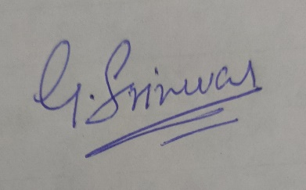
G. Srinivas
Roll no:- 62

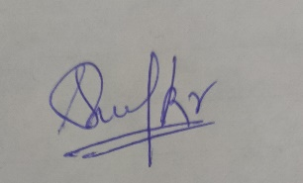
Anoop kumar
Roll no :- 63


Goutam Abrol
Roll no :-65
Place: Lovely Professional University
Date: OCT-27,2020

Table of Contents

TITLE PAGE NO.
1.Background and objectives of the project assigned
1.1 Project overview
1.1.1 Motivation
1.1.2 Goals and objectives
2.Description of project
3.Description of work division
4.Implementation of Scheduled work
5.Technologies and framework used

BONAFIDE CERTIFICATE

Certified that this project report “ Parking Management System in Python Project” is the bonafide work of “G.srinivas , Anoop kumar , Goutam abrol ” who carried out the project work under my supervision.

Sagar Pande
Asst professor
23754
Department of computer science
engineering

1. Background and Objectives of the Project assigned

Project Overview: Parking Management System in this we can enter the details about the owner and their vechicles for Parking , it follow some procedure according to this you have to create account and enter your details.
The system can eroll the data of vechicle in the parking management database. We can also see the previous data .
This Project has been developed in aim of aid computerized,so how can we become isolate and untouched from environment . That’s why keeping this in mind and an
opportunity or probably a creativity to do such a task in a different way and unique from others.
Motivation : Our subject teacher sahil sir has motivated towards this interesting project and he explained each and every detail briefly. With the help of our notes and learnings
during the classes we made this project without any kind of similarity with other projects that are
allocated to every groups in our class.
Outcome of project: On the completion of this interesting project we came to learn many new things and how we can provide data into the database which will help in our future and what we expected exactly same we achieved by doing work in coordination, continuous working by each member of group without wasting any time we were able to complete this project within
the given time frame with our diligent work.
Goals and Objectives: Understand and implement Tkinter, datetime ,SQLite and database by python.

2. Description of Project
Parking management system will hold the information of owner of the vechicle and vechicles in which there are many options like Name, lastname, Gender, age, aadhar no., mobile no., address ….etc. First we create account for which will like to park their vechicles.
Admin is the main authority who can do addition, deletion and modification of user data.

Parking management system is usefull in the parking department of Malls , Hospitals ,universities… etc to enter the data of vechicles and their owner. Can also view data he entered, add entry, Update, delete, close are also available in the database.

We have given option for password for user to login entry the data of vechicles and about their owner in database. Password is mandatory to enter or change the data of the vechicles in data base.

3. Description of Work Division

Name of the group member | Work distributed
- G. Srinivas | Given the code for GUI used in our program liker tkinter
- Anoop kumar | Given the idea of this project. And Given code for login page and other coding part
- Goutam abrol | Given code for page of entering data of vechicles in database

G.Srinivas: he has taken responsibility of making the window page to enter the password And help in implementing tkinter .He has done all his work under the given frame with perfection .
Anoop kumar :.He give the idea of project and He has also collected the information about the project and images requied to the project.and other done other coding parts.

Goutam Abrol: He has written code for the entering data in database management system. He played a vital role in the project for making the code perfect of our project.

4. Implementation of Scheduled work of project
This is how our code works

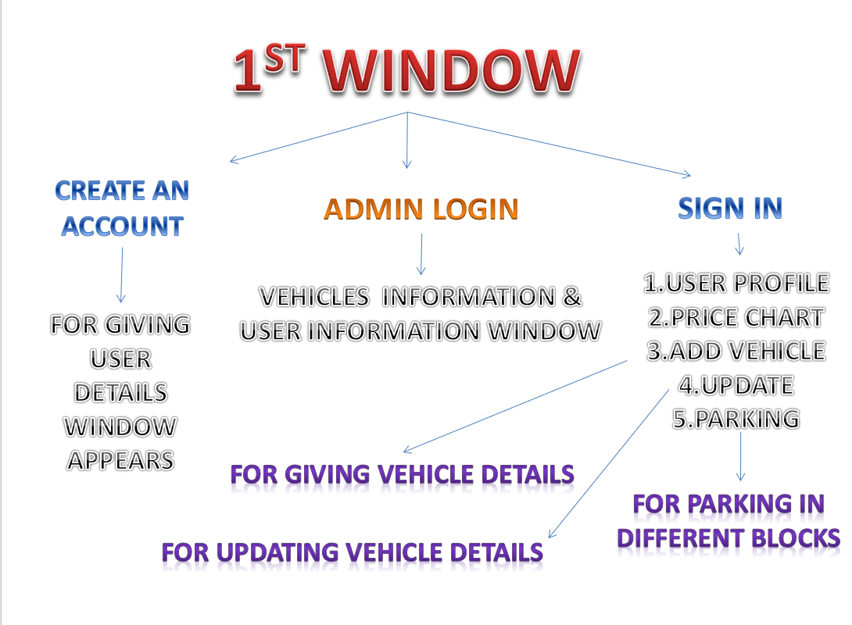

[A] this is look of window-
This is our homepage.After enetering the password module [2] will open.
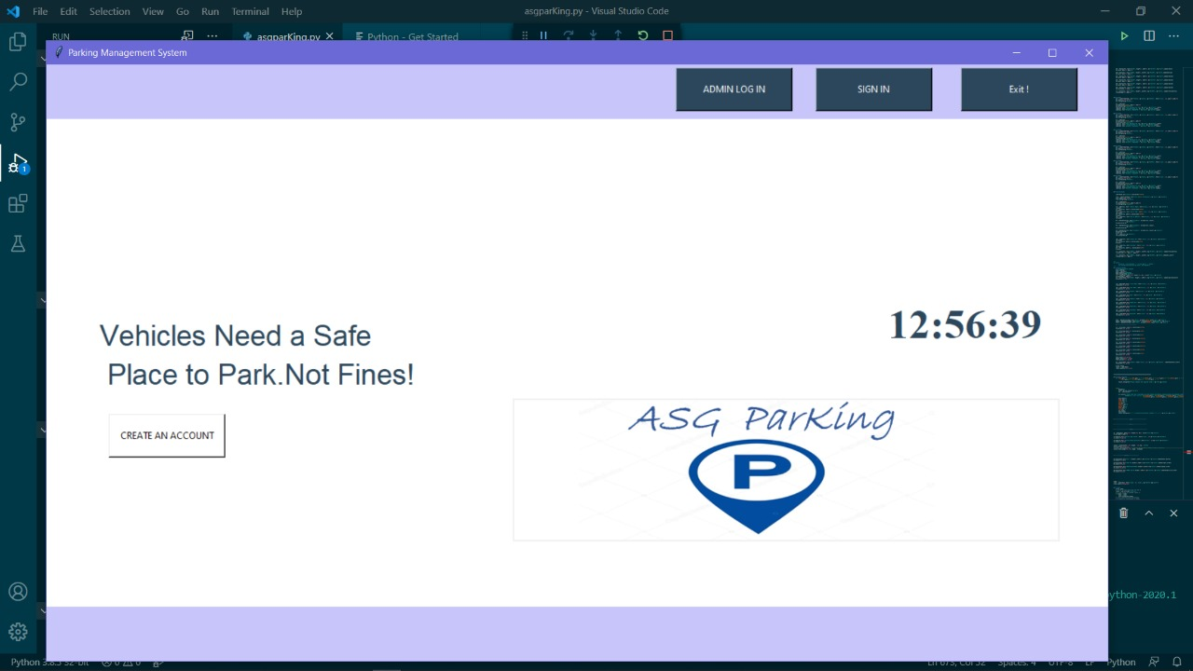

[2].Here we can enter the data of vechicles owner by the user.
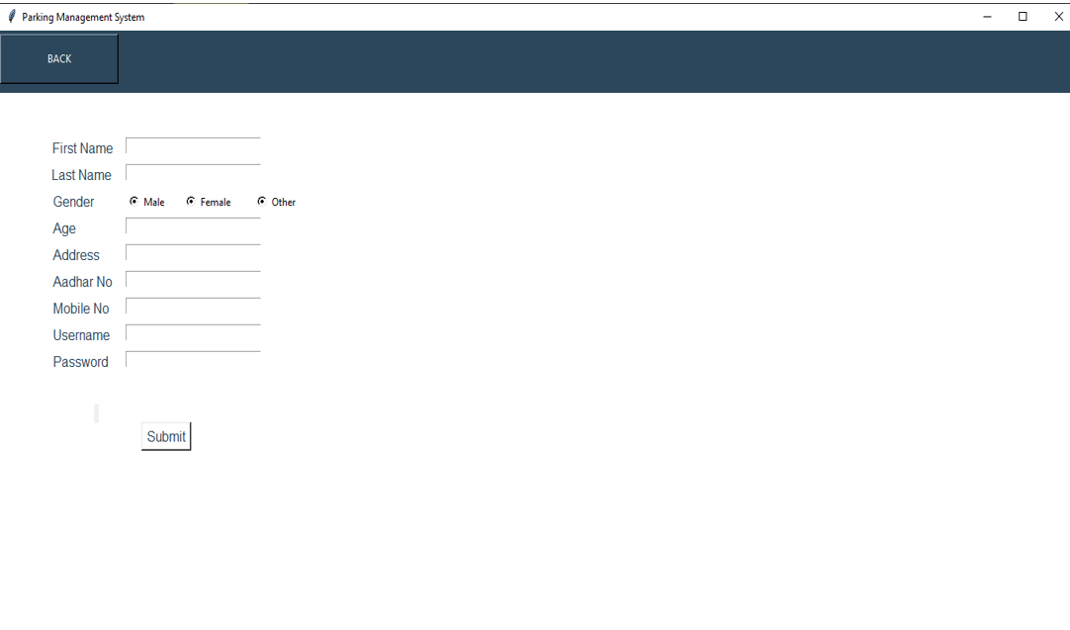

5. Technologies and Framework to be used
We used IDLE 3.6 for writing the code. SQLite for the database

THANK YOU

